Key words: RNN, attention,

Objective: Arm Tracking(not recognition)

Hardwares:

指南针：给出地磁北极方向，收地磁场波动影响，在室内可能失准。

重力计：给出地心引力方向，收其他加速度影响，在运动时失准。

陀螺仪：给出角速度，在计算角度时误差会积累。

Comments:

* Why RNN performs better in the long term compared with traditional methods when compute the device orientation?

RNN is good at dealing with time-series data. It will consider the data from multiple time steps, but the traditional sensor fusion methods (A3, MUSE) only consider the data from previous time step.

* Think about the applications or postures to motivate HMM model is not efficient. (HMM, no. RNN, yes.)
* For attention scheme, how to assign weight automatically and dynamically. What is the rational of attention?
* Another possible neural network architecture, get the orientation first and then incorporate the orientation and acceleration data to get the location, and update the orientation at the same time.
* Keep in mind the spatial correlation within data .

Paper Outline:

1. Motivation experiments. The goals of motivation are twofold. First, we justify RNN is better than HMM (a, b, c). Second, attention is necessary (d).

a.     HMM is too slow. Increase the sampling rate and the point cloud of first-order HMM model to show its inefficiency.

b.     The contradict between accuracy and efficiency of HMM. Do experiments to show the accuracy and computation of second-order and third-order HMM.

c.      RNN can approach the best combination scheme of all three inputs (gyroscope, acc, and mag) in a data-driven way.

d.     Do experiments to show the necessity of attention mechanism.

o   Spatial: Do experiments to show if magnetic north will change when the arm is moving but the human does not move. Gravity can be accurately extracted from accelerometer when the device is static or moving slowly, but not accurate when the device is moving fast.

o   Temporal: Current location and orientation are not THE MOST related to the location and orientation of the last time steps（?,202108150900）, but some previous time steps may have a higher influence on the current location and orientation.

1. Design

a.     Overview: our system has three novel contributions.

a.     Multi-task learning for both location and orientation with a same RNN model.

Multi-task: Track both location and direction.

b.     Attention from time and spatial perspectives.

Attention mechanism assigning weight to different sensor?

c.      DRL to incorporate domain knowledge. （）

                                                                          i.      Short-time gyroscope accuracy

                                                                          ii.      Moving speed relative to the human body can be accurately measured(Doppler Profiling).

                                                                          iii.      The arm of human cannot move freely, the valid moving locations can be **got(Adjust, not acquire directly)** from the human arm motion model.

b.     Design a RNN (based on LSTM) architecture to predict 3D orientation and 3D location at the same time based on multi-task learning.

c.      Design attention-based network adaption from spatial perspective  and time perspective

o   Spatial perspective: automatically increase the weights for valid inputs and substantially decrease the weight for invalid parts. The magnetic north is valid when the standard deviation of magnetic field density variation is small. The gravity (accelerometer) is valid when the device is static or moving slowly.

o   Time perspective: automatically assign higher weights to the hidden state at time t-2 than time t-1 when the hidden state at time t-2 is more related to the orientation estimation than hidden state at time t-1.

d.     Design a DRL model on top of RNN model to refine the RNN model by considering the short-time gyroscope accuracy, the moving velocity obtained from acoustic signals and the human arm motion model in reward function.

e.     Suppose every user has to train her own RNN model. How to justify the training process for each user is efficient?

Perhaps the concept of federated learning could help. We train a universal model first for all first-time users. Users would further refine their local model while simply using the device, because it is a DRL based algorithm. Counter-wise, local users’ models could also be uploaded to the server and help update the universal model. （饼已经画的很大，是否还要Fed learning的概念？）

f.       How to scale the system to different users and/or different environments?

1. Experiments

a.     Collect data.

b.     Synchronize data between smartwatch and Oculus to label the data.

Motivation:

1. Replace HMM with RNN.
   1. RNN could be fast than HMM on forward. HMM O(N^2 T)
      1. N，没有搜索精度问题
      2. T，采样率，5Hz可能不行
2. Orientation深挖，因为过去的工作的Orientation可能不准。

遗留问题：

1. 《Real-time Arm Skeleton Tracking and Gesture Inference Tolerant to Missing Wearable Sensorsw》为什么一开始不用RNN做（读introduction，找motivation）
2. 表是戴在手腕上还是小臂上？
   1. 手腕乱动会影响方向。
   2. 手臂的方向自由度更小。

**先做手臂**

1. 具体应用场景？
2. Orientation 网络的更新只用
3. TensorFlow Lite，找中文教程

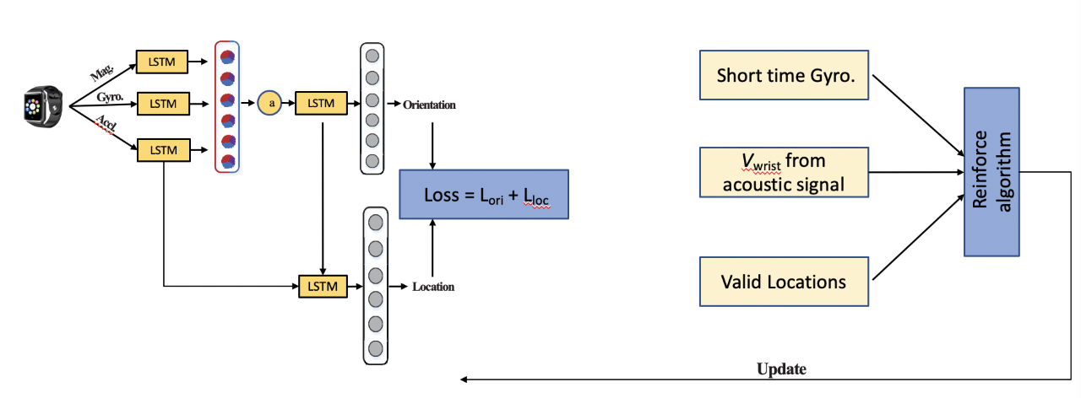

NSDI？